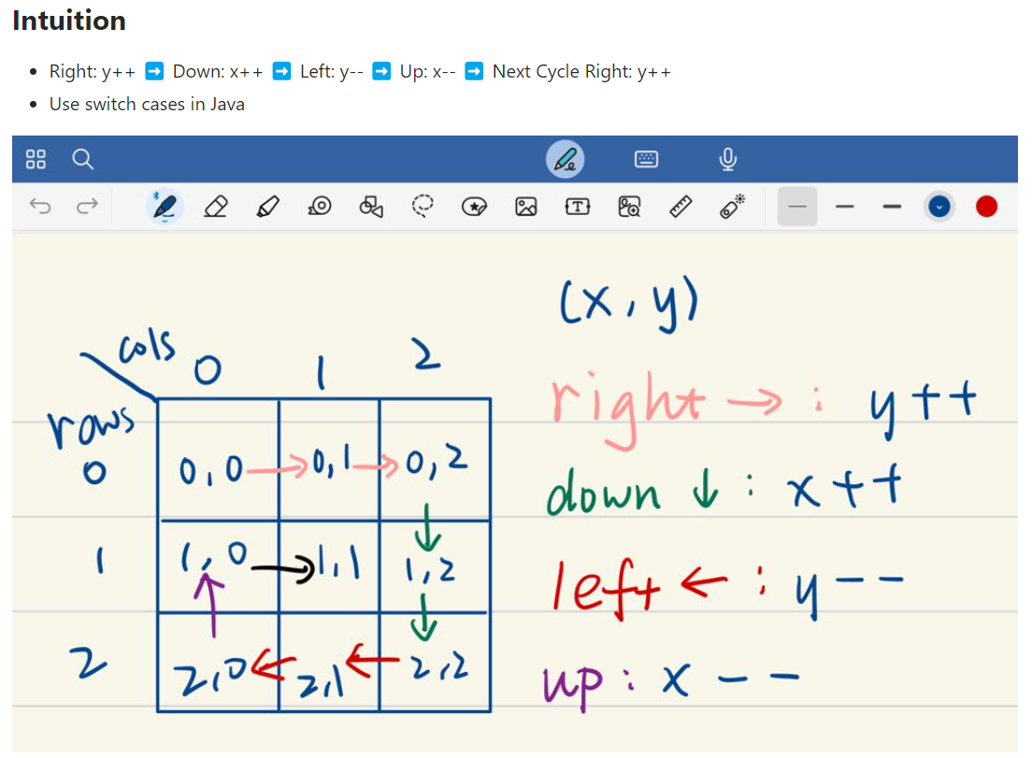
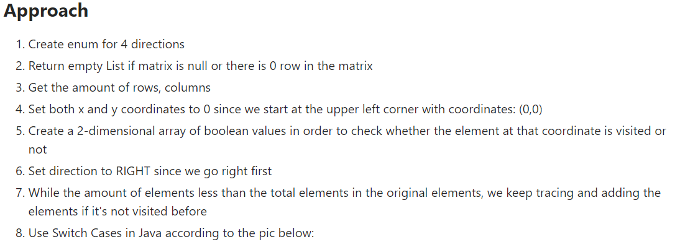
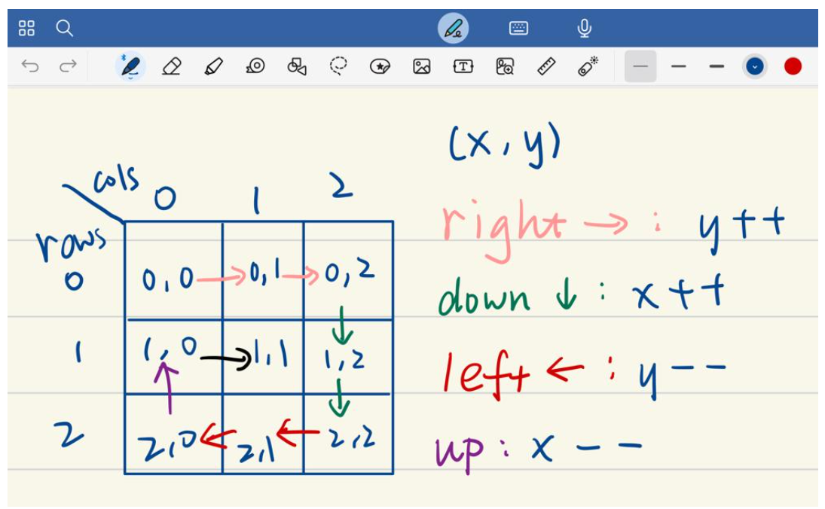
- case RIGHT:
- Increase the y-coordinate by 1 if the next column is not the last column (column: cols - 1) as well as the next element is not visited.
- Otherwise, increase the x-coordinate by 1 to go down.

- case DOWN:
- Increase the x-coordinate by 1 if the next row is not the last row (row: rows - 1) as well as the next element is not visited.
- Otherwise, decrease the y-coordinate by 1 to go left.

- case LEFT:
- Decrease the y-coordinate by 1 if the next column is not the column that beyond the first column (column: 0) as well as the next element is not visited.
- Otherwise, decrease the x-coordinate by 1 to go up.

- case UP:
- Decrease the x-coordinate by 1 if the next row is not the row that beyond the first row (row: 0) as well as the next element is not visited.
- Otherwise, increase the y-coordinate by 1 to go right for the next cycle until all the elements in the matrix are visited.

